Stand alone cluster without any configurations.

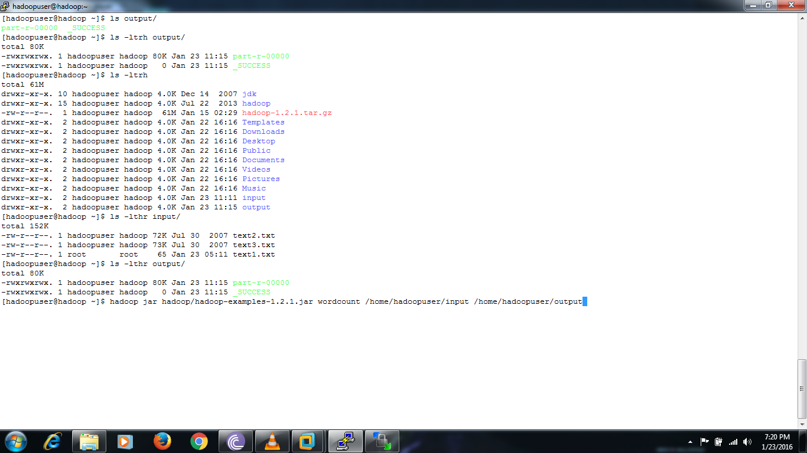

Stand alone cluster after Map reducing programs



SINGLE NODE CLUSTER :

